CpE 111 Homework Assignment #7 Maximum – 100pts

HW#7 is due at the beginning of class on Apr 17, 2006. You must always show or explain your work in a neat and orderly format. You are encouraged to discuss ideas with other students and consult references but your work must be your own.

1. Consider two 4-bit words

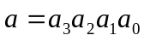
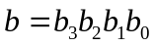

Design a logic component (i.e., internal circuitry) that produces an output of h = 1 when the two conditions 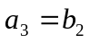and 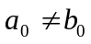are simultaneously true.

2. Design an active-low 2/4 decoder using NOT gates and OR gates only.

3. Construct 4:1 MUX using only 2:1 MUXs as the main building blocks.

4. Use an 8:1 MUX to implement the function

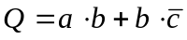

5. Perform the following binary additions without using decimal equivalents. (15pts)
(a) 1101 0110 + 0100 1100
(b) 1101 0000 + 1010 1010
(c) 1010 1010 + 1111 0001

6. Perform the following subtractions by translating into binary and applying the 2s complement approach. Use word size of 8b. (20pts)
(a) 15 – 6
(b) 34 – 20
(c) 136 – 62
(d) 196 – 114

7. Perform the following binary multiplications. (15pts)
(a) 1011 x 1011
(b) 1110 x 0110
(c) 1011 x 0110
(d) 0101x 1011

8. Design a transmission gate network that implements the function

